Case 2-Afr-Egy-Apis Bull-Bronze
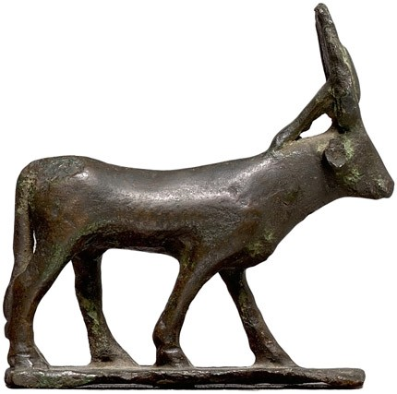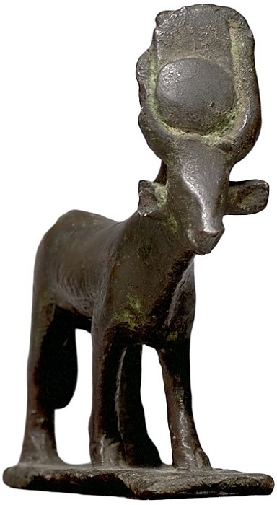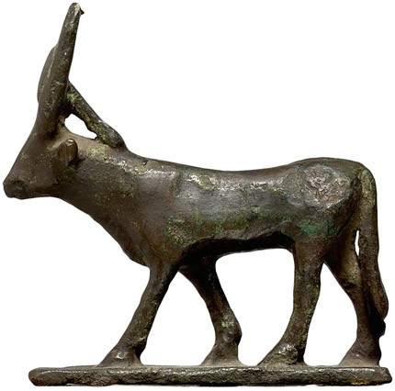
Case No.:
Accession Number:
Formal Label:
Display Description:
This ancient Egyptian bronze Apis Bull with a uraei-kalathos headdress, a cobra in an upright position who was the protector of the king, an agent of his destructive powers symbolized by its spitting fire and a figure associated with the goddess Wadjit.
LC Classification:
Date or Time Horizon:
Geographical Area:
Map:
GPS Coordinates:
Cultural Affiliation:
Medium:
Dimensions:
Weight:
Provenance:
Condition:
Discussion:
References:
Berk, Harlan J. Egyptian Bronze Apis Bull Inv.# aq17797, Price: $4500.

